Assessment 2- Part 2 (Team 5)

Due any time before 17:00 hrs on July 13th, 2020

**Instructions**

**This assessment will require to work again in the first part (the one you sent to me early on) but as a team. Besides, in the next page there are two problems requiring calculations**

# Instructions for working again in the Assessment 2-Part 1

1. **You should get together with your teammates to solve as a group, the questions you answered in the Assessment 2-Part 1 and have to write down for each question the following:**
2. *Rephrase the problem indicating very clearly what you have been asked to do.*
3. *List all the data provided.*
4. *Make a list of the assumptions. justifying each of them.*
5. *Write down an algorithm for the solution you are proposing (no calculations are needed at this stage)*
6. *Answer the question*
7. *if needed check in the web for technical papers to support your answer.*
8. *List the references used in the solution of the problem.*

# Question 1

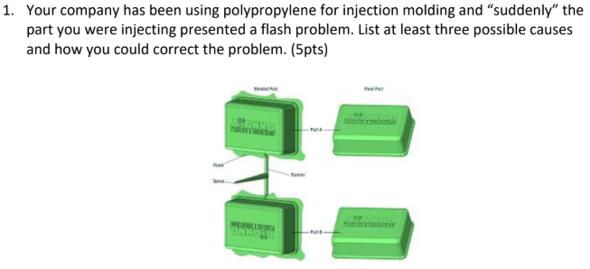

## Rephrase the problem

We are asked to mention three potential causes for a flash defect in the parts, and their possible solutions.

## List all the data provided

* Problem: Flash defect
* Polymer: Polypropylene
* Process: Injection molding

## Make a list of the assumptions. justifying each of them

3 possible causes could be errors in the injection molding operation.

1. The pressure or temperature of the injection is higher than needed: higher pressure and temperature in the injection shot allows an easier flow in the mold, causing the problem.
2. Gap within the mold: Improper molding conditions could also cause the flash defect.
   1. Not having enough clamping force in the mold allows an excess of material in the part.
3. Other causes: higher temperature than needed in the mold, higher processing time, improper mold design, the mold might be old and have cavities.

## Write down an algorithm for the solution you are proposing

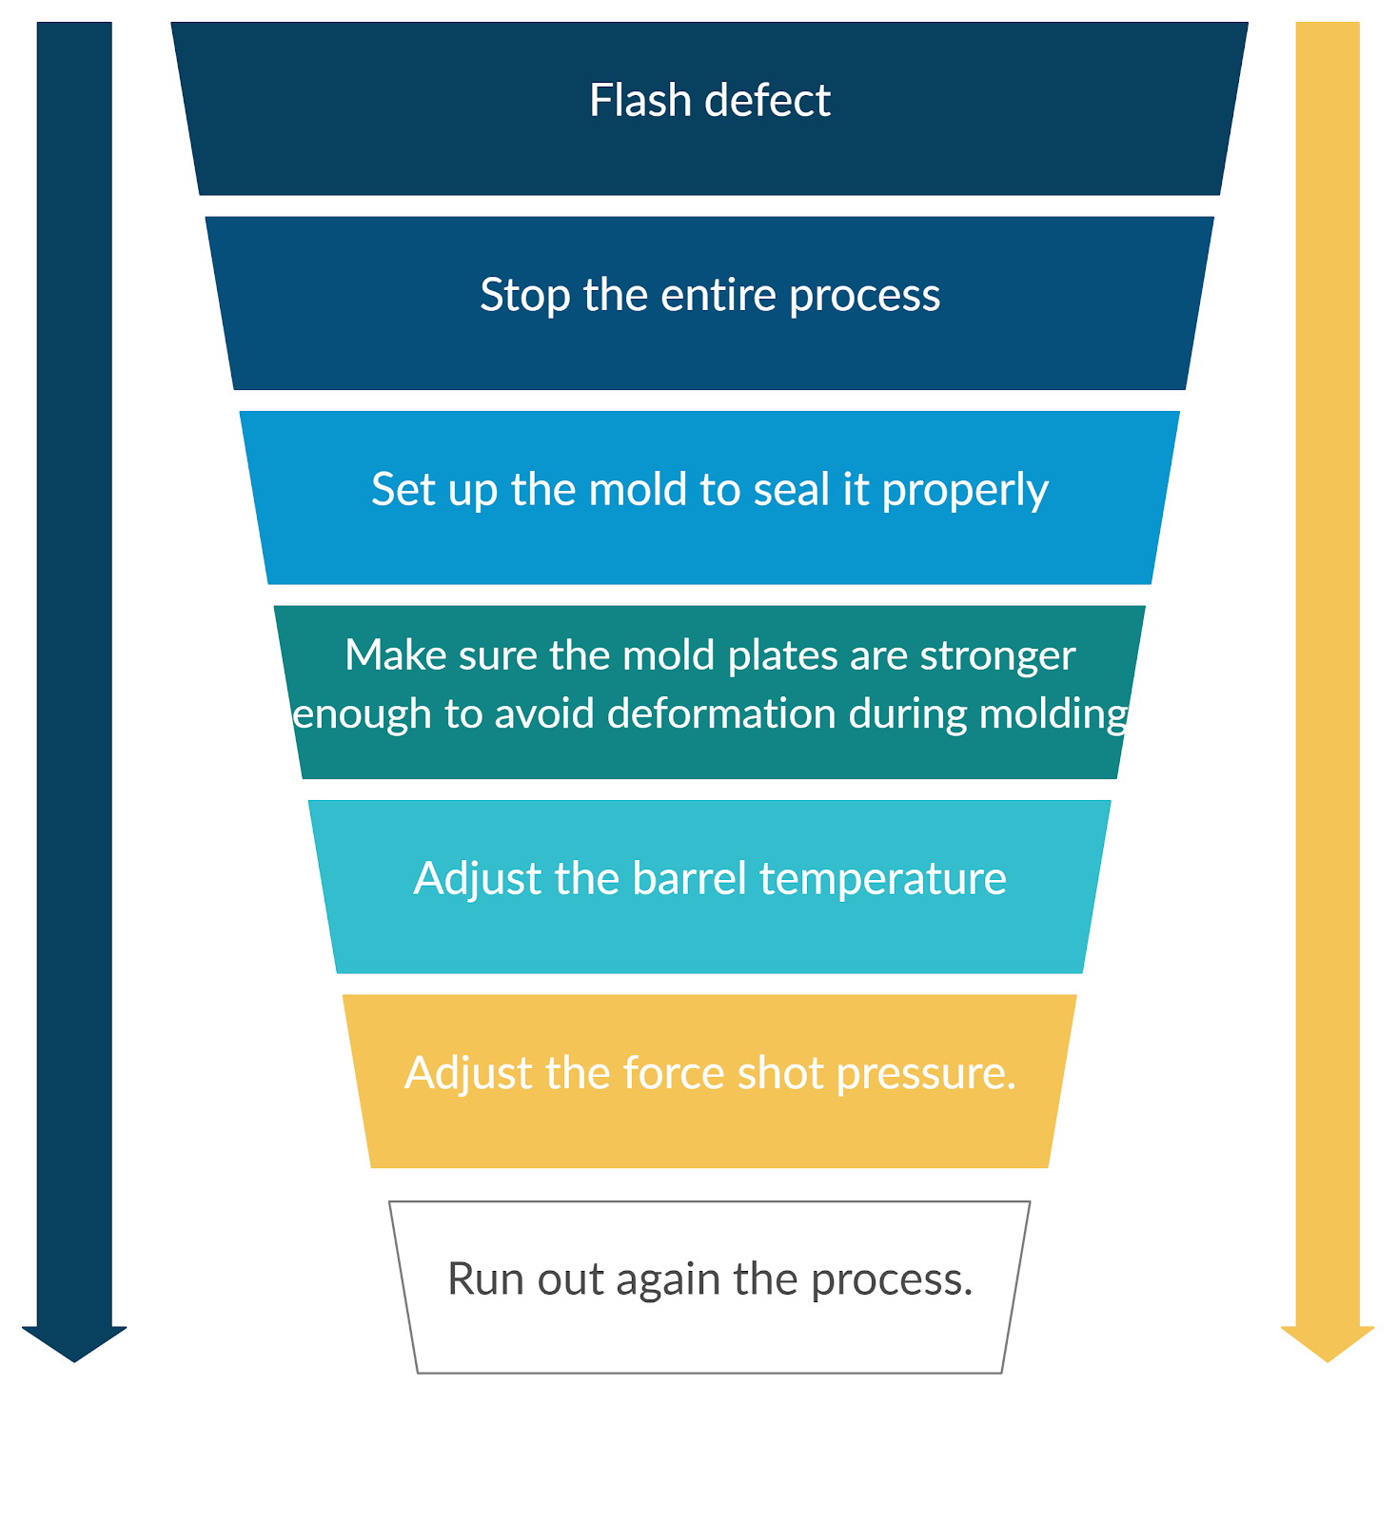

## Answer the question

In general, the problem needs an analysis for the entire process, while focusing on the following:

* Adjustment of the screw temperature and the injection pressure to reduce the injection force and the polymer flow speed into the mold.
* Increasing the clamping force 10-20% to ensure the mold is not going to leave any gaps while receiving the injection pressure, without affecting the mold.

## References

Rosato, D. V., & Rosato, M. G. (2012). Injection molding handbook. Springer Science & Business Media.

# Question 2

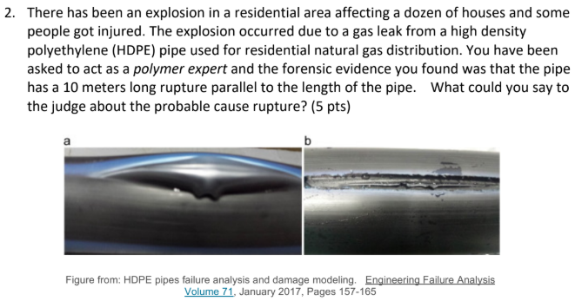

## Rephrase the problem

Ten meters long rupture of a high density polyethylene pipe by natural gas distribution. What could we say about the possible cause?

## List all the data provided

* Problem: The explosion occurred due to a gas leak from HDPE pipe used for residential natural gas distribution.
* Polymer: High density Polyethylene
* Uses: Pipes for residential natural gas distribution.
* Other: The pipe has a 10 meters long rupture parallel to its length.

## Make a list of the assumptions. justifying each of them

1. Damage during maintenance and manipulation:
   1. The material was correctly manufactured but incorrectly manipulated: allowing stress cracks, in certain tube length zones from accidental hits.
   2. Wrong maintenance: Assuming that the pipe was used normally after certain period of time, the leak occurred at a location where the maintenance was done.
2. Damage during pipe’s manufacture:
   1. An inappropriate mixture of the polymer during the process.
      1. Pellets with different sizes: It produces a mix between melted and unmelted polymer, allowing some regions weaker than others.
      2. Additives missing: Allows material to become permeable under severe environmental and operating conditions.
      3. Wrong velocity and temperature in the screw: Similar to pellets with different sizes; unbalance mixing and melted times produce defects in the final product.
   2. The way the material is pushed into the die.
      1. Temperature, pression and velocity affect the polymer through the die.

## Write down an algorithm for the solution you are proposing

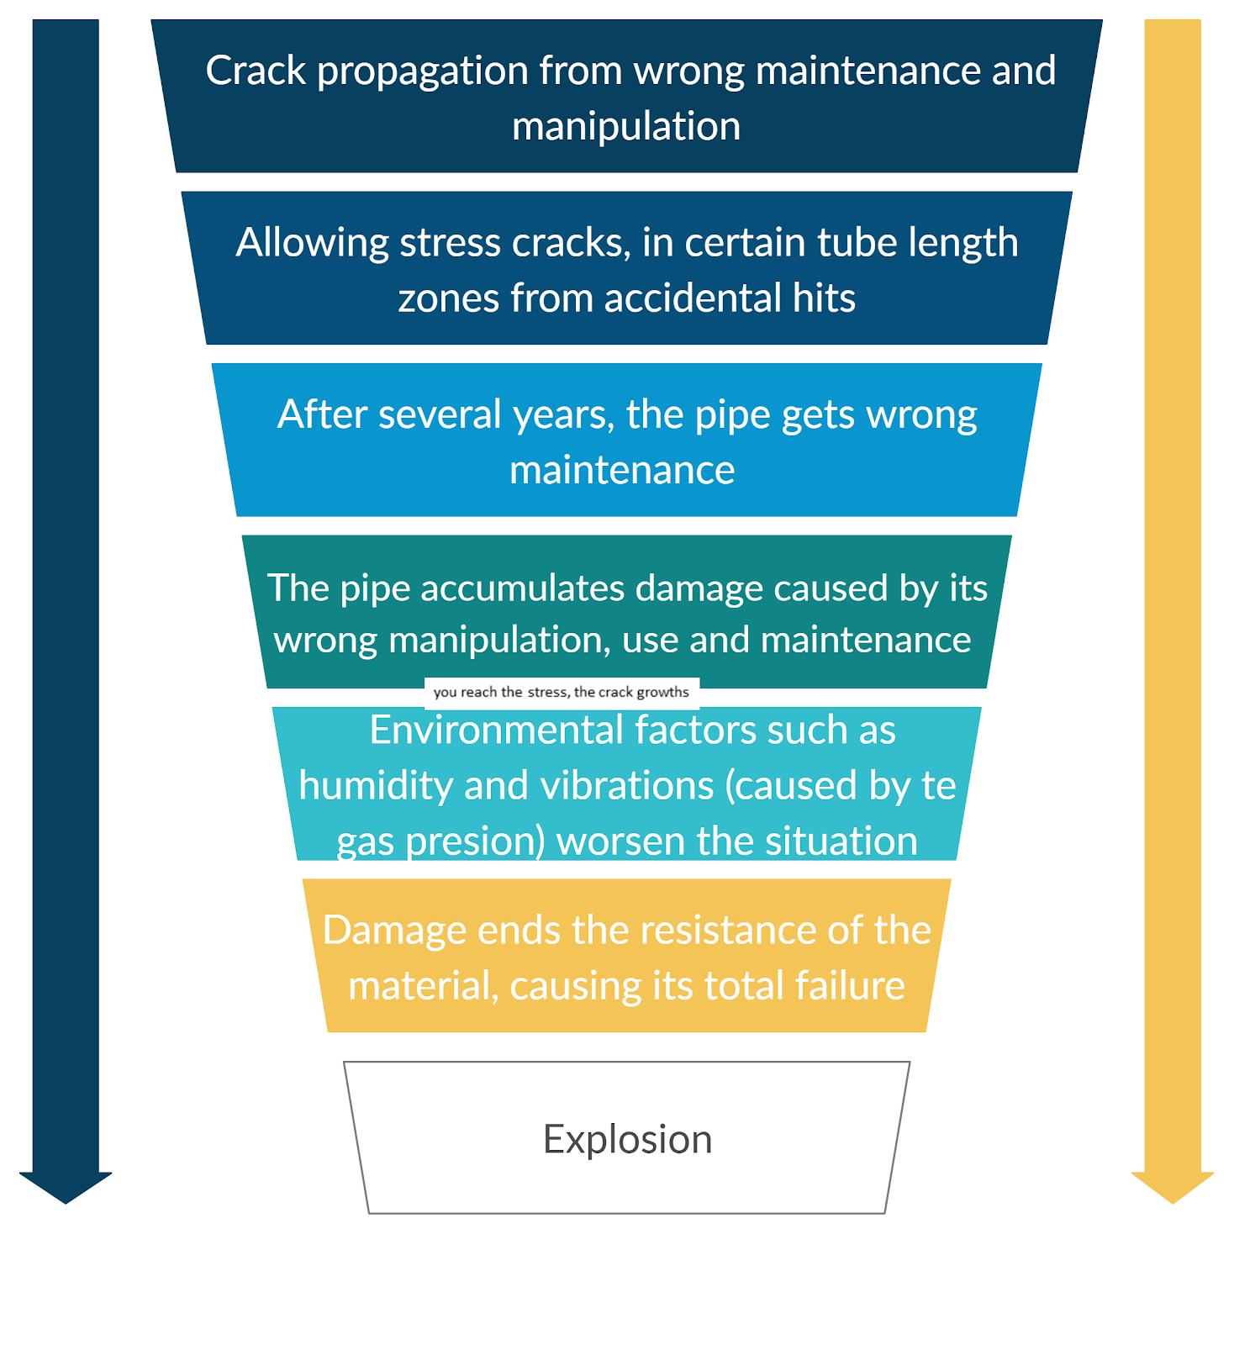

Damage during maintenance and manipulation.

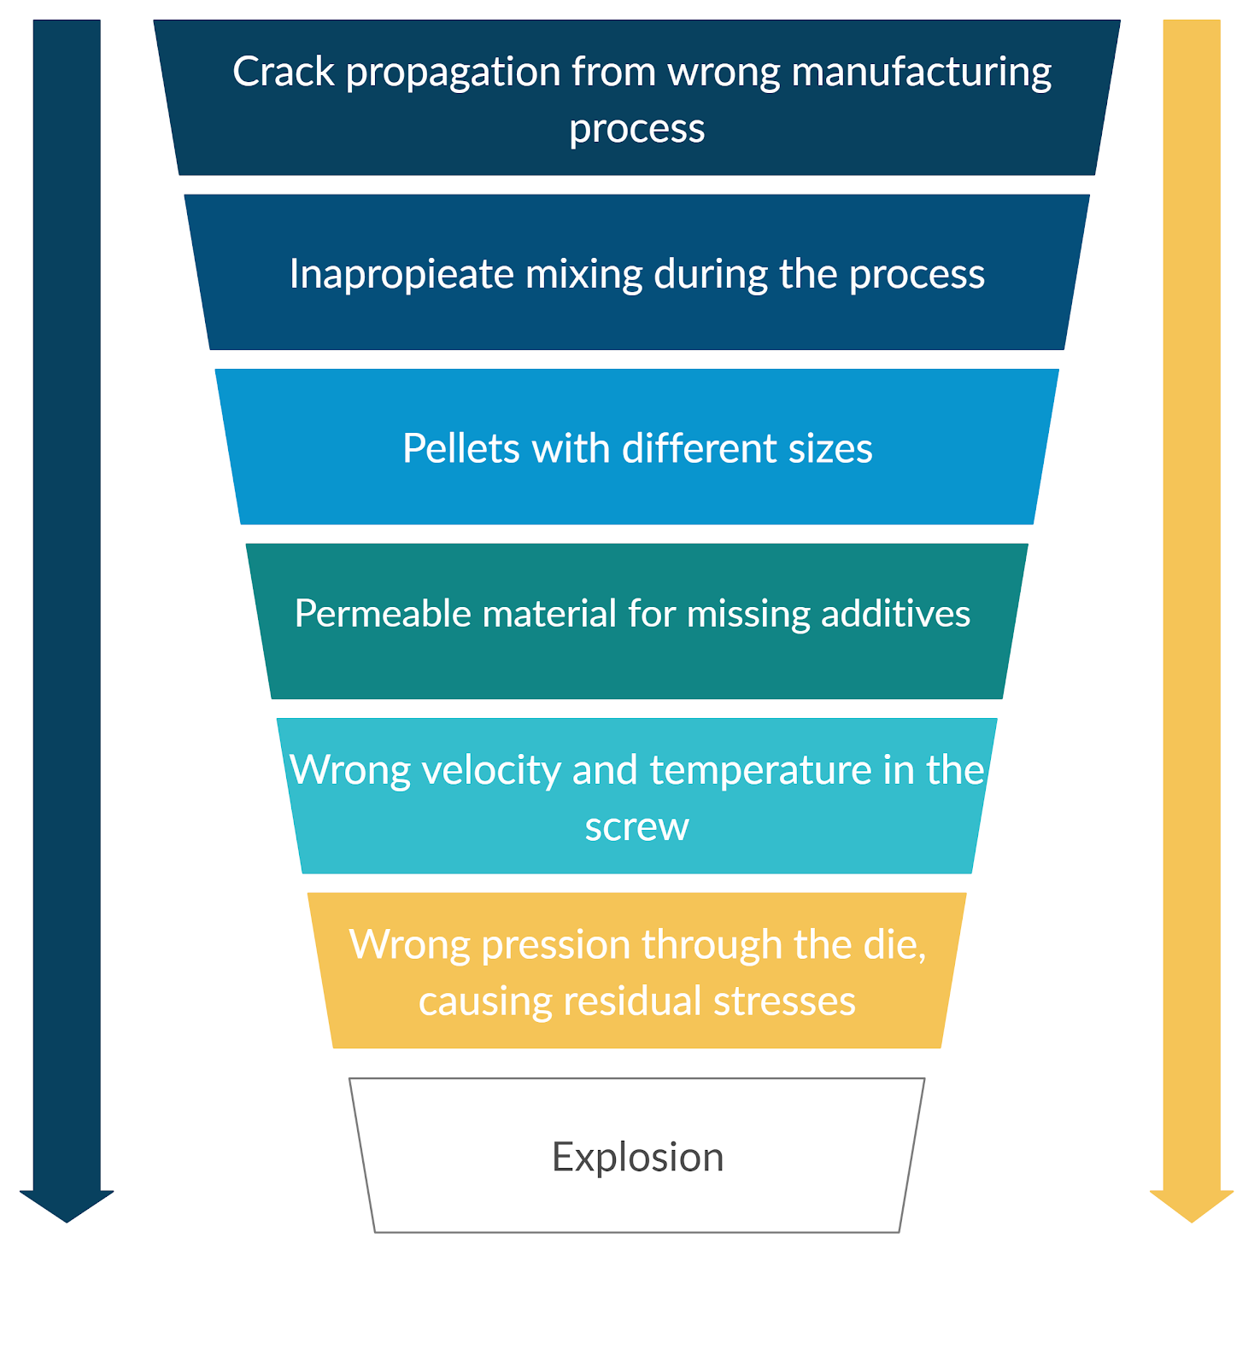

Damage during pipe manufacture

## Answer the question

There are two possible major reasons:

1. From the maintenance and manipulating perspective:
   1. Wrong handling and maintenance cause damage in areas where there was no damage, producing microstructural cracks that later get worse with the gas pressure. Also, wear due to pressure flow, and environmental factors such as humidity and vibrations make the situation worse. Eventually, damage ends the resistance of the material, causing the explosion.
2. From the production perspective:
   1. There was an improper mixture of the polymer, creating clusters in the semi-crystalline structure of the material, which when extruded, leave some regions weaker than others. This causes the polymeric chain alignment to go in the same direction as the pressure of the water because of the extrusion, thus breaking the pipe in a longitudinal manner. Also, uneven cooling during extrusion may have left residual stresses that with time and usage become cracks.

## References

Jones Jr, R. E., & Bradley, W. L. (1993). Failure of a Squeeze-Clamped Polyethylene Natural Gas Pipeline. ASM International, Handbook of Case Histories in Failure Analysis., 2, 482-486.

Naebe, M., Abolhasani, M. M., Khayyam, H., Amini, A., & Fox, B. (2016). Crack damage in polymers and composites: A review. Polymer reviews, 56(1), 31-69.

# Question 3

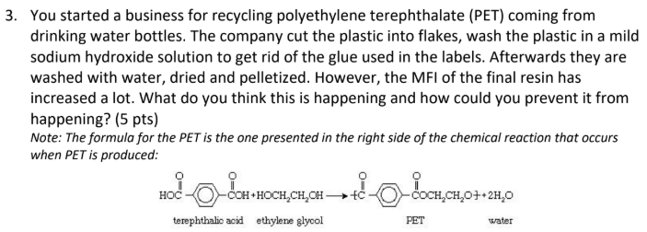

## Rephrase the problem

PET water bottles are being recycled from different sources, then cut into flakes, washed and turned into pellets. New water bottles are being made from the resulting pellets but the melt-flow index is too high, meaning that the viscosity has decreased.

## List all the data provided

* Problem: High melt flow index
* Material: Polyethylene terephthalate
* Source: Recycled water bottles

## Make a list of the assumptions. justifying each of them

1. The resulting resin is being used to make new water bottles because they are recycling PET exclusively from drinking water bottles.

2. Manufacturing conditions are properly applied, because otherwise there would be other defects present in the resulting water bottles.

## Write down an algorithm for the solution you are proposing

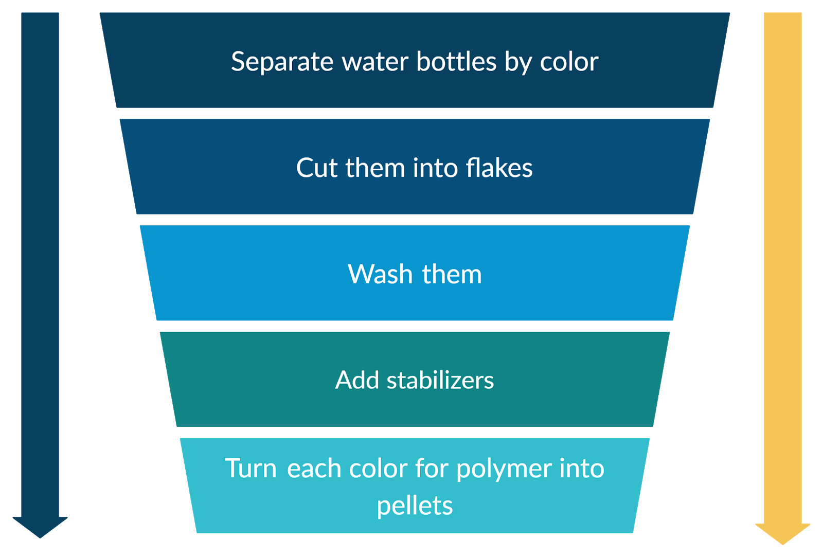

## Answer the question

Due to the recycled resin coming from different manufacturers, each type of water bottle has their own additives, concentrations, and treatments. Mixing them into one resin may cause it to have unexpected results in terms of properties and probably branching copolymerization.

Our solution proposal is to separate water bottles by colors and make resins of each kind while adding stabilizers like new PET (25% new PET with 75% recycle PET) to avoid having unexpected reactions.

## References

Koltzenburg, S., Maskos, M., & Nuyken, O. (2017). Polymer Chemistry. Berlin, Germany: Springer. https://doi.org/10.1007/978-3-662-49279-6

# Question 4

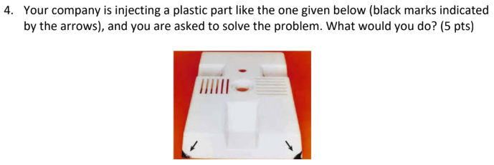

## Rephrase the problem

The plastic part injected is having black marks in the edges (corners) and needs to be solved.

## List all the data provided

* Problem: Black marks.
* Process: Injection molding.
* Material: Plastic.

## Make a list of the assumptions. justifying each of them

1. The part is made of a thermoset polymer.
2. The black marks are due to a Diesel effect.
3. All processing conditions are well established.
4. There is an air venting problem.

## Write down an algorithm for the solution you are proposing

**If** vents are clogged {

Clean vents

} **else** {

Redesign the vent within the die

}

Install vacuum system {aid the air to escape the mold}

## Answer the question

As it was mentioned in the assumptions, the problem is most likely to air and other gases not escaping properly due to vents being clogged. When injecting polymer into a mould, air and other gases need to escape the mould through vents. If the air/gas does not escape fast enough, pressure builds up inside the mould. Polymers under pressurized conditions heat up and the "diesel effect" takes place, carbonizing some of the polymer. The result is charcoal-like edges in the final product. The solution would be to redesign/clean the air vent and slow the injection process to allow proper air circulation, and if possible, add a vacuum system to extract the air from the mold, which with time would be less expensive than slowing down the process.

## References

Plastics Technology. How to Fix Outgassing Problems in Injection Molding (2018) https://www.ptonline.com/articles/how-to-fix-outgassing-problems-in-injection-molding#:~:text=Gas%20and%20air%20entrapment%20can,output%20in%20the%20molding%20process.

Injection molding presentation by Dr. Jaime Bonilla Ríos

# Question 5

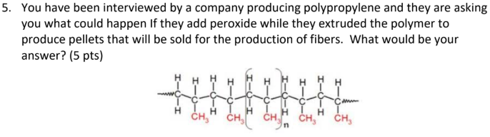

## Rephrase the problem

A company wants to add peroxide to polypropylene while extruding it, to produce pellets for fibers. What will happen if they do this?

## List all the data provided

* Process: Extrusion.
* Material: Polypropylene.
* Additive: Peroxide.
* Purpose: Pellet production for fibers.

## Make a list of the assumptions. justifying each of them

* The modification of PP’s molecular architecture with peroxides is focused on obtaining a more adequate rheological response for those processes that require high resistance to melt. In few words, they want to improve the stability of the polymer for future fiber’s manufacturing, by adding peroxides.
* There are different types of peroxides, we will assume we are using the most compatible type for polypropylene.

## Write down an algorithm for the solution you are proposing

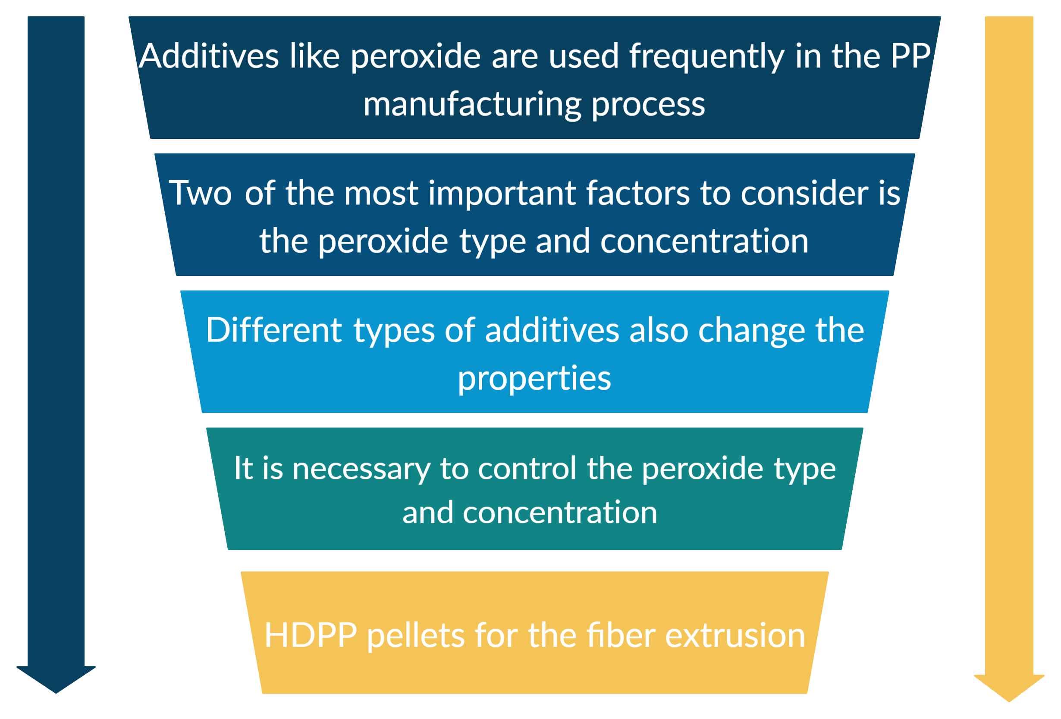

## Answer the question

Free radical polymerization will take place. Peroxides are organic radical sources. During free radical polymerization, a radical (created from the decay of peroxides) adds to the double carbon to carbon bonds of a monomer, resulting in a new radical extending from the monomer unit. The result would be polymeric pellets with a higher molecular weight.

Nevertheless, one of the most important factors to consider is the peroxide concentration;

* An excessive amount in it could allow the breaking of PP chains instead of causing branching reactions, thus leading to a decrease in the weight average molecular weight of PP and also, changing the desired mechanical properties.
* At low peroxide concentrations, coupling reactions are observed, which can give non-desired properties.

## References

Polyvel. Peroxide Rheology (Melt Flow) Modifiers. () https://www.polyvel.com/products/peroxides/

SALAZAR, M. L. G. (2014). Modificación estructural de polipropileno empleando iniciadores cíclicos multifuncionales triperóxido de dietilcetona (TPDEC) y diperóxido de pinacolona (DPP), en conjunto con extensores de cadena del tipo acrilato.

Kim, B. K., & Kim, K. J. (1993). Cross‐Linking of polypropylene by peroxide and multifunctional monomer during reactive extrusion. Advances in Polymer Technology: Journal of the Polymer Processing Institute, 12(3), 263-269

# Question 6

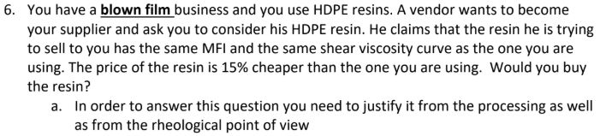

## Rephrase the problem

We use HDPE resins in a blown film industry. A vendor is offering us a resin with, allegedly, the same MFI and same shear viscosity curve as the one we have, but 15% cheaper. Would we buy the resin? We should justify the answer from the processing and rheological point of view.

## List all the data provided

* Process: Blown film.
* Material: HDPE resin.
* Material characteristics: “Same resin, MFI, shear viscosity curve”, and cheaper.

## Make a list of the assumptions. justifying each of them

1. Our enterprise has the necessary equipment to test a sample of the resin, just for proving its properties and compare them before doing the purchase.
2. It doesn’t matter if the vendor is already known in the polymer’s market for quality products, or not.
3. Resin has the same shear viscosity curve and same MFI of our resin.

## Write down an algorithm for the solution you are proposing

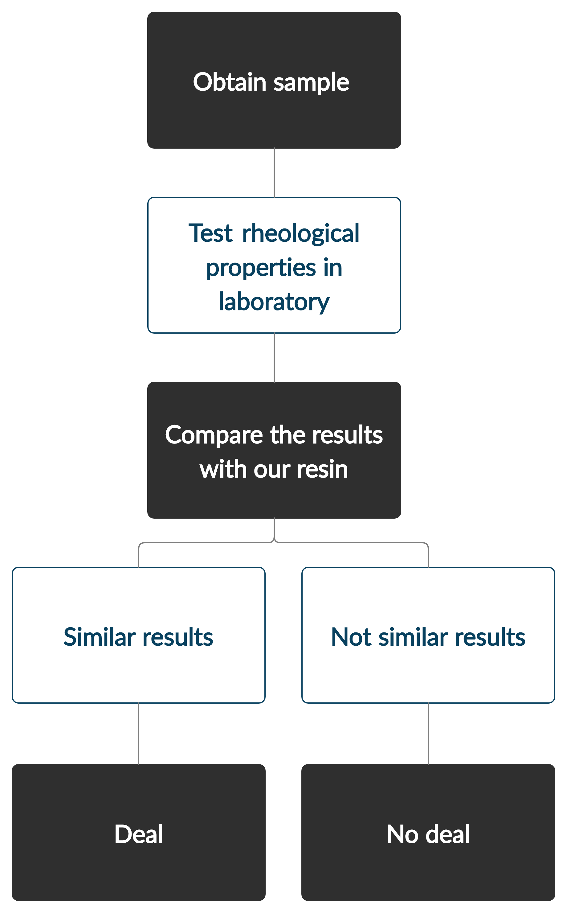

## Answer the question

We would request a sample from him to run some rheology tests to ensure that his claims are true. If indeed they are true, we would buy his resin to reduce production costs while maintaining the same properties in our products.

Blown film processes are used to manufacture very thin films. It is not possible to make the profile of the die as thin as needed without the back pressure becoming too high, these thin films cannot be extruded directly, in such a way that the rheological properties of the melt play an important role. As soon as the film leaves the die it is inflated by pressurized air. Depending on the speed of the extrusion and the pressure of the air flow, the film becomes thinner. The tubular film is then cooled while maintaining a blown form. The viscosity of the polymer melt dictates the size of the die and therefore the features of the final product, in this case it is imperative to ensure the MFI is the same, thus, having the same rheological properties as our resin.

## References

Plastics Technologies. A Film Processor’s Guide to Understanding Materials & Equipment. (2016) https://www.ptonline.com/articles/a-film-processors-guide-to-understanding-materials-equipment

# Question 7

  
 

## Rephrase the problem

The company wants to switch resins from polypropylene to polyester. What type of recommendations would we give them to ensure quality control of the product, such as mechanical properties?

## List all the data provided

* Material: From polypropylene to polyester
* Problem: Ensure mechanical properties

## Make a list of the assumptions. justifying each of them

Despite the difference in properties, the use of both resins can be justified for similar products with different mechanical properties, specifications and prices. Nevertheless, it is necessary to take the next considerations:

1. The company has the necessary resources and laboratory equipment.
2. Switching the resin to produce a different product:
   1. If the manufacture process is already adapted for polypropylene, it would be necessary to adapt it again for polyester, too (velocity, temperature and type of screw, pression, cooling system, additives, mold, die, etc.). The properties of the desire product also will change, but changes ensure that the quality is going to be maintained.
3. Switching the resin to produce the same product:
   1. If the above is not possible, it would be necessary to modify the rheological properties of the polyester resin (by using additives) to adapt it to the process and the desired properties of the final product.

## Write down an algorithm for the solution you are proposing

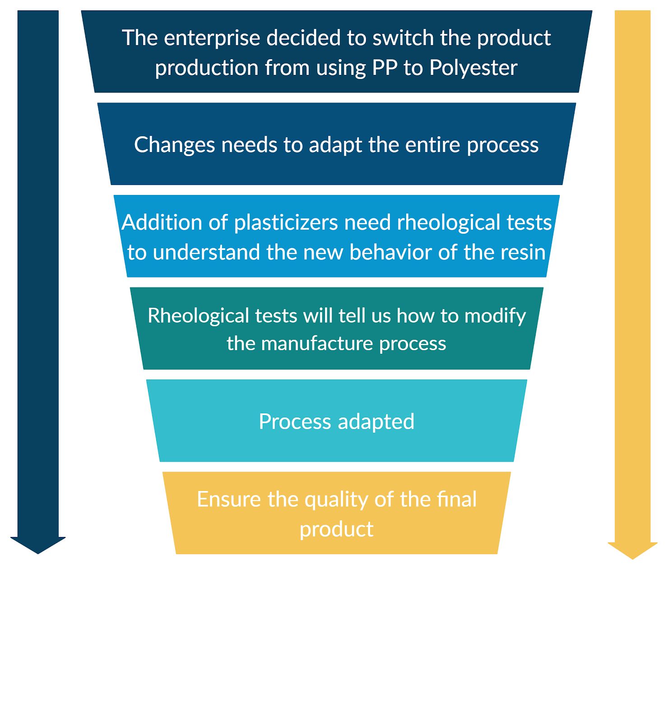

## Answer the question

The use of additives to adapt the process will change the rheological (Tg, Mw, MFI and DPI) and mechanical properties of polyester making them similar to those of polypropylene. Understanding their new properties will be critical to ensure the quality of the final product while adjusting the manufacturing process to match the new rheological and mechanical properties.

## References

No references needed for this module.

# Question 8

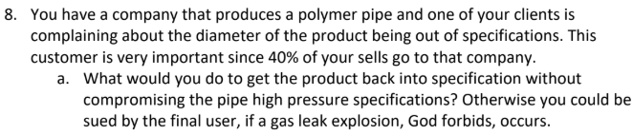

## Rephrase the problem

The company produces polymer pipes and a client is not satisfied with the diameter, claiming that is out of specifications. 40% of the sells go to that client, what can we do to ensure the product is back into specification without compromising high pressure specifications?

## List all the data provided

* Application: Pipes
* Problem: Diameter out of specifications
* Ensure high pressure specifications

## Make a list of the assumptions. justifying each of them

1. The pipes are made through extrusion.
2. The diameter is bigger than specified.
3. The polymer is swelling after extrusion being the most probable cause for the unmet specifications.
4. The pipes are made through extrusion.
5. We have a laser micrometre that feeds a signal to the microprocessor which adjusts the screw or puller speeds

## Write down an algorithm for the solution you are proposing

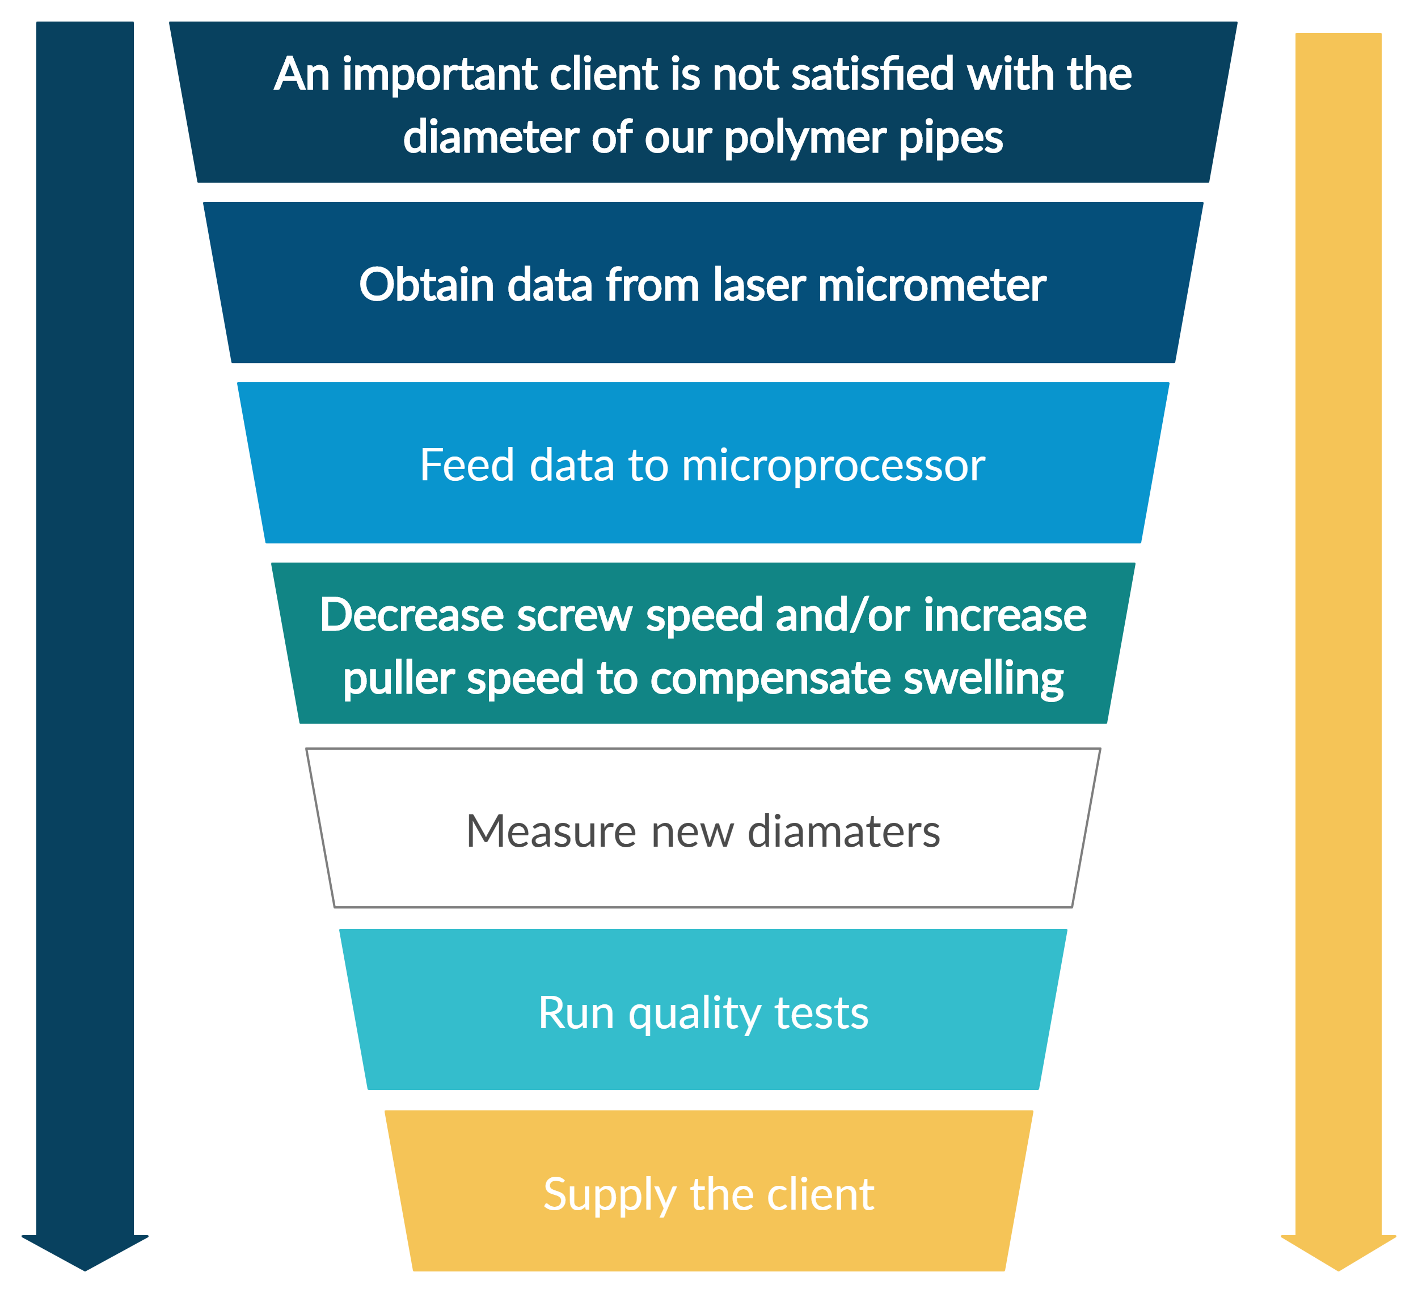

## Answer the question

We proposed a cost-effective solution, instead of changing the die (which is very expensive), we will adjust the screw and puller speeds to compensate for the diameter changes. If the diameter is too large the extruder screw speed has to decrease, or the puller speed has to increase. A balance between pulling speed and screw speed needs to be optimized to achieve the desired pipe diameters without overheating the screw or an over alignment of crystalline structures within the polymer.

## References

Giles Jr, H. F., Mount III, E. M., & Wagner Jr, J. R. (2004). Extrusion: the definitive processing guide and handbook. William Andrew.

# Question 9

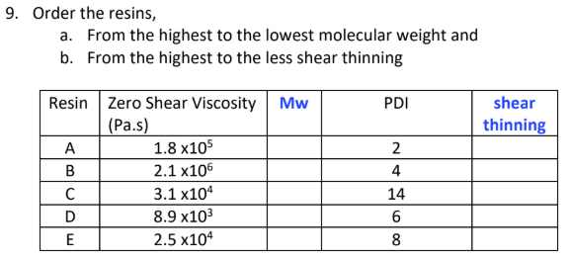

## Rephrase the problem

Order the resins from highest to lowest molecular weight and from highest to less shear thinning.

## List all the data provided

* Zero shear viscosity
* Polydispersity Index

## Make a list of the assumptions. justifying each of them

* If the PDI is higher then, the shear-thinning behavior is higher, because there is more variation of chain lengths.

## Write down an algorithm for the solution you are proposing

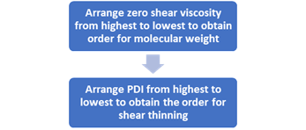

## Answer the question

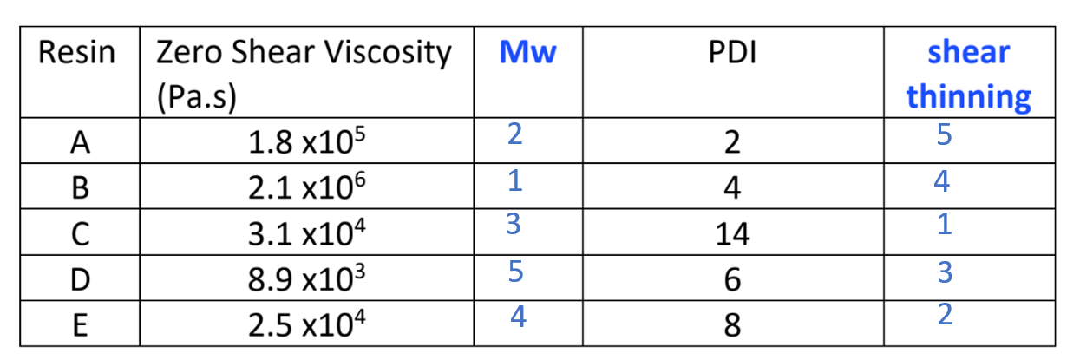

## References

Chemical nature of polymers presentation by Dr. Jaime Bonilla-Ríos

# Question 10

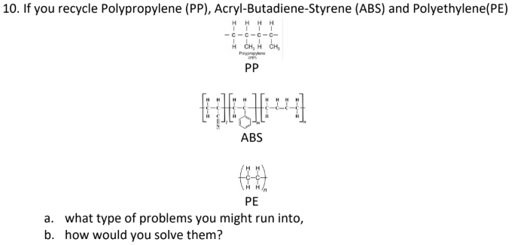

## Rephrase the problem

We are recycling PP, ABS, and PE. What problems could we encounter and how would we solve them?

## List all the data provided

* Source: Recycled materials
* Material: PP, ABS, PE
* Problem: MFI increase

## Make a list of the assumptions. justifying each of them

## Write down an algorithm for the solution you are proposing

## Answer the question

## References

Recycle Nation, The Most Difficult Plastics to Recycle. (2011) https://recyclenation.com/2011/03/difficult-plastics-recycle/

# Instructions for working again in the Assessment 2-Part 2

1. **You should get together with your teammates to solve as a group, the questions you answered in the Assessment 2-Part 1 and have to write down for each question the following:**
2. *Rephrase the problem indicating very clearly what you have been asked to do.*
3. *List all the data provided.*
4. *Make a list of the assumptions. justifying each of them.*
5. *Write down an algorithm for the solution you are proposing (no calculations are needed at this stage)*
6. *Solve the problem*
7. *Ask yourself if the result is reasonable and, if needed check in the web for technical papers to support your answer.*
8. *List the references used in the solution of the problem.*

I strongly suggest to you to work on your own in steps A to D so you can make an honest contribution to the team, *afterwards you can work E to G with the other members of the group.*

**PROBLEMS**

# Problem 1 (Filling a mold)

1. Calculate the pressure required to fill the mold.



* The dimensions (in cm) of each cavity are 10x10x1
* The runners’ diameter is 1 cm and their length are indicated in the drawing.
* The polymer is a polypropylene (PP) with a density of 0.9 g/cm3
* The viscosity curve for the resins is given in the document called PPVIS 2020:
  + Groups 1 and 3 should work with resin PAR0
  + Groups 2 and 4 should work with resin PAR3
  + Groups 5 and 6 should work with resin PAR5
* The injection is done at the red dot.

## Rephrase the problem

Calculate the necessary injection pressure to properly fill the given mold through the injection molding processing method.

## List all the data provided.

* Mould geometry (cavities and runners)
* Polymer: polypropylene (PP) density
* PP viscosity data
* Point/location of injection

## Make a list of the assumptions, justifying each of them.

The following is assumed for simplicity and easy the analysis effort

* The polymer behaves as the Power Law model
* The material density remains constant through the whole process
* The melt flow is identical in the cross-sectional area (asymmetric flow)
* The melt flow is is fully developed (constant velocity at a given pressure)

## Write down an algorithm for the solution you are proposing.

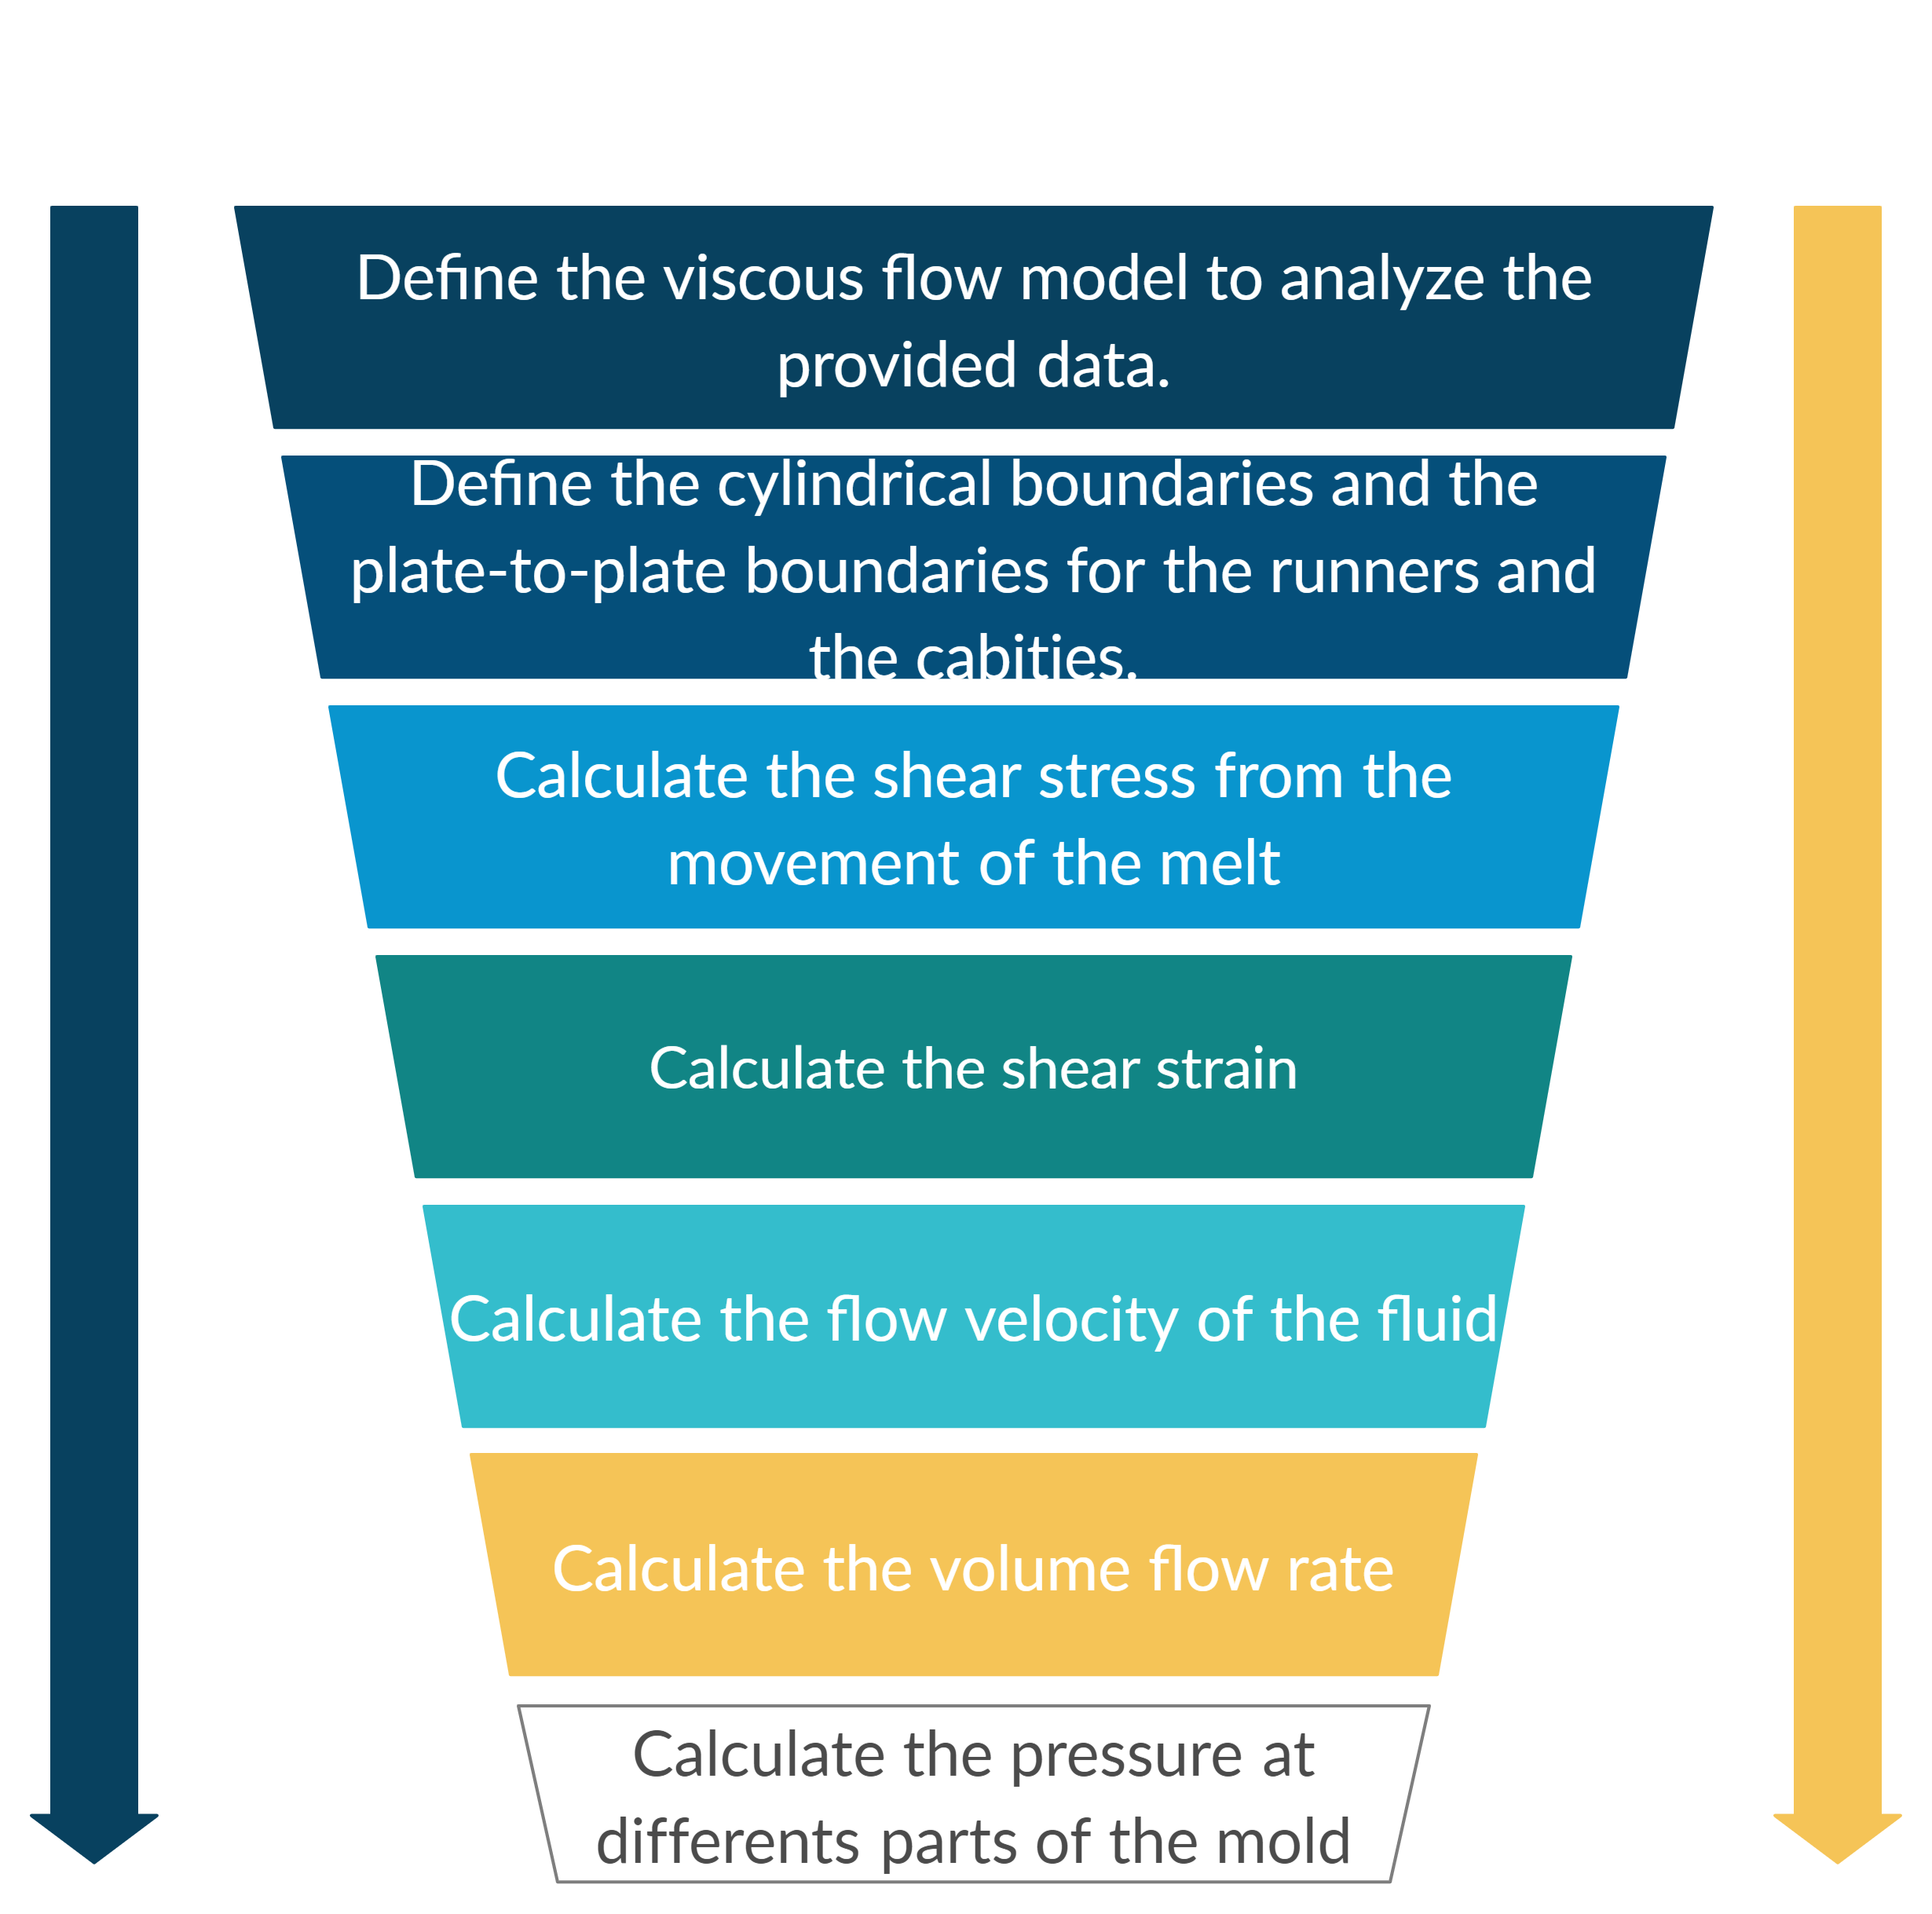

## Solve the problem

The following is adapted from the problem-solving reasoning of Dantzing et al. [1].

### The Viscous Flow Model

Several models have been proposed in literature with different number of fitting parameters. The purpose of these models is to obtain analytical solutions in polymer processing, and to measured data. The flow behavior of different fluids, different models better fit them as some fluids may be shear thinning and/or experience a yield stress.

Complex models such as the Carreau-Yasuda model better represent the rheological behavior of the polymer but can add significant difficulty to the analysis of the data. As depicted in the following figure, the Carreau-Yasuda model better fits the given data than the Power Law model.

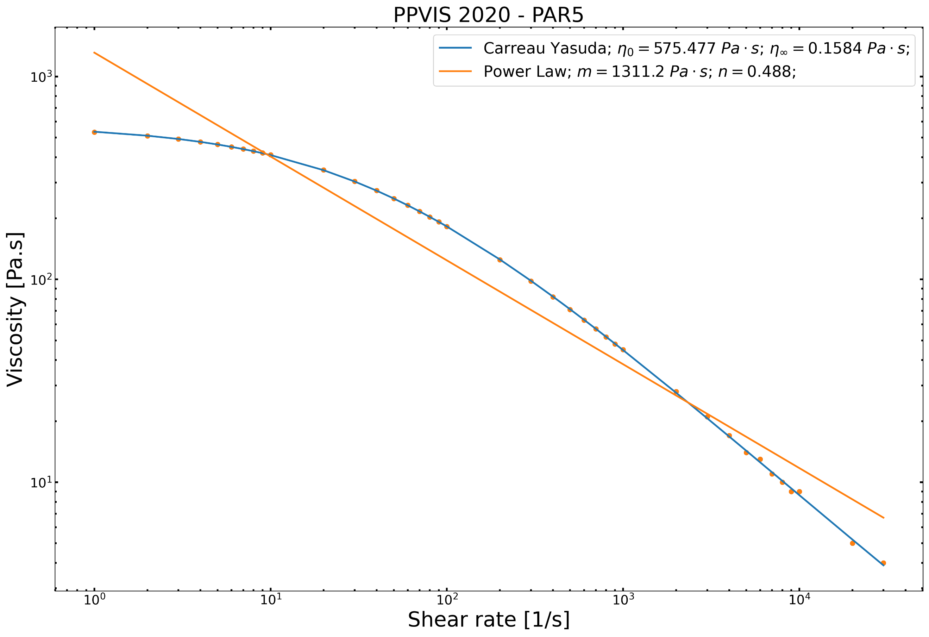

#### The Carreau-Yasuda Model

$$η=\frac{η_{0}-η_{∞}}{{\left[1+{\left(κ\dot{γ}\right)}^{a}\right]}^{\frac{1-n}{a}}}+η_{∞}$$

Where:

$η in Pa⋅s$*is the viscosity*

$\dot{γ} in 1/s$*is the shear rate*

$η_{∞}=0.158429 Pa⋅s$*, is the infinite shear rate viscosity*

$η_{0}=575.477 Pa⋅s$*, is the zero-shear rate viscosity*

$κ=0.0259115 N s^{n}/m^{2}$*, is the time constant*

$n=0.244547$*, is the Power Law index*

$a=0.716978$*, is the width of the transition region between the zero-shear viscosity and the Power Law region.*

#### The Power Law Model

$$η=m {\dot{γ}}^{n-1}$$

Where:

$η$*is the viscosity*

$\dot{γ}$*is the shear rate*

$m=1311.2 N s/m^{2}$*, is the consistency index*

$n=0.488$*, is the Power Law index*

For this examination, the Power Law model is used for simplicity. Its imperative to mention that the Power Law model assumes that: *a) $η<η_{0}$, b) $η>η_{∞}$, c) $η_{∞}=0$, d) $a=1$, and e) $κ=m$*  [2]. If n < 1 the fluid is shear thinning, and if n > 1 it has a shear-thickening behavior.

### Pressure Flow Within the Runners

#### Define the Cylindrical Boundaries

From the power law model, let us consider the flow of a power law fluid in a circular tube to describe the mold runners and assume that the density of the material is constant. From Appendix B.2 in [1], let us define the tube boundaries by selecting the continuity equation for constant density, in cylindrical coordinates:

$$\frac{1}{r}\frac{∂}{∂r}\left(rν_{r}\right)+\frac{1}{r}\frac{∂ν_{θ}}{∂θ}+\frac{∂ν_{z}}{∂z}=0$$

Where:

$ν_{r}$ is the flow velocity through the wall

$ν_{θ}$ is the flow velocity at the circular plane

$ν_{z}$ is the flow velocity in the z-direction (lengthwise)

Assuming the flow is identical in every $θ$ plane (asymmetric flow), the second term $\frac{∂ν_{θ}}{∂θ}=0$, and in the assumption that the flow is fully developed (same/constant velocity along the cylinder at a given pressure), then $\frac{∂ν_{z}}{∂z}=0$. Giving: $\frac{1}{r}\frac{∂}{∂r}\left(rν_{r}\right)=0$. By integrating the previous, the following is given:

$$ν_{r}=\frac{C_{1}}{r}$$

Where the constant $C_{1}=0$ because $ν_{r}$ is zero since no fluid is leaking the boundary. Also, due to axisymmetric flow, $ν_{θ}=0$. Therefore, the given assumptions and boundary conditions conclude that the only velocity is in the z-direction.

#### Calculate the shear stress through the movement of the fluid

Again, from Appendix B.2 in [1] let us define the momentum equation in the z-direction to describe the flow/motion of the fluid:

$$-\frac{∂}{∂z}p+\frac{1}{r}\frac{∂}{∂r}\left(rτ_{rz}\right)+\frac{1}{r}\frac{∂}{∂θ}τ_{θz}+\frac{∂}{∂z}τ_{zz}+ρb_{z}=0$$

Again, the asymmetry assumption makes $\frac{∂}{∂θ}τ_{θz}=0$, and the fully developed flow assumption makes $\frac{∂}{∂z}τ_{zz}=0$. Also, $b_{z}=0$ as the effect of gravity or electromagnetic fields are neglected. With a constant $\frac{∂}{∂z}p$ due to the fully developed flow assumption. Giving the following z-direction momentum equation:

$$-\frac{∂}{∂z}p+\frac{1}{r}\frac{∂}{∂r}\left(rτ_{rz}\right)=0$$

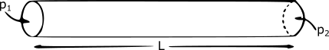

Following the shape in the figure above, the change in pressure can be described as:

$$\frac{∂}{∂z}p=\frac{p_{2}-p_{1}}{L}=-\frac{Δp}{L}$$

Where:

$p_{1}$ is the pressure leaving the cylinder

$p_{2}$ is the pressure entering the cylinder

$L$ is the length of the cylinder

$Δp$ is negative as the shear stress is not in the positive direction of z

By substituting the previous two equations:

$$-\frac{Δp}{L}=\frac{1}{r}\frac{∂}{∂r}\left(rτ_{rz}\right)$$

Integrating the previous, gives: $τ_{rz}=-\frac{Δp}{2L}r+\frac{c_{2}}{r}.$ Where the constant $c_{2}=0$ to prevent the infinite values of shear stress when the radius $r=0$. Such that the shear stress is given by the following for a steady, fully developed axisymmetric flow in cylindrical boundaries.

$$τ_{rz}=-\frac{Δp}{2L}r$$

#### Calculate the strain rate

For cylindrical coordinates (Appendix B.3 in [1]) and the Power Law, the strain rate can be described as $\dot{γ}=\frac{∂}{∂r}ν_{z}$, with $ν_{r}=ν_{θ}=0$ and $ν_{z}$ as a function of the radius $r$.

By substituting $\dot{γ}$ in the Power Law model, we have: $τ_{rz}=\frac{∂mν_{z}}{∂r}{\left(-\frac{∂}{∂r}ν_{z}\right)}^{n-1}$. On the other hand, the velocity at the tube wall $ν_{r}$ shall decrease from its maximum value (at $r=0$) to zero, hence $\frac{∂}{∂r}ν_{z}<0$. Therefore, the shear stress can be written as

$$τ_{rz}=-m{\left(\frac{∂ν_{z}}{∂r}\right)}^{n}$$

#### Calculate flow velocity in the z-direction

By matching the values of $τ_{rz}$ of the previous sections, we have: $-m{\left(\frac{∂ν_{z}}{∂r}\right)}^{n}=-\frac{Δp}{2L}r$. If $s=n^{-1}$, then:

$$\frac{∂ν_{z}}{∂r}=-{\left(\frac{Δp}{2mL}\right)}^{s}r^{s}$$

Integrating the radius $r$ from 0 to $R$ we have:

$$ν_{z}=\frac{1}{s+1}{\left(\frac{Δp}{2mL}\right)}^{s}\left(R^{s+1}-r^{s+1}\right)$$

According to the Power Law model fitting parameters we have $s=\frac{1}{n}=\frac{1}{0.488}=2.049$ and $m=1311.2 Pa∙s$

For a Newtonian fluid, $s=1$, in this case $s>1$ as we are dealing with a shear thinning fluid.

#### Calculate volume flow rate $Q$ passing through the runner

The calculation is to be done by integrating the velocity $ν_{z}$ over the cross section over $θ$, as follows:

$$Q=\int_{0}^{2π}{\int_{0}^{R}{ν_{z}\left(r\right) dr dθ}}=\frac{π}{s+3}{\left(\frac{Δp}{2mL}\right)}^{s}R^{s+3}$$

The $n=0.488$ represents a significant level of shear thinning. When $s=2.049$, $Q$ is proportional to ${\left(Δp\right)}^{2.049}$, meaning that doubling the pressure drop will quadruple the flow rate. The higher stress near the walls leads to a lower viscosity, and the lower viscosity requires an increased shear rate to sustain the higher shear stress. At the center of the tube the shear stress is small, so the viscosity is high in that point. Shear-thinning behavior is advantageous in the extrusion of polymers. Inside the runner the shear rate is large, so the polymer has a relatively low viscosity, and the pressure drop across the runner is not too high. However, once the polymer exits the die it is subjected only to stresses from its own weight, which are small. Under these low stresses the polymer has a high viscosity, which helps it holds its shape as it cools in the cavities.

Therefore, the pressure entering the runner $p_{2}$ can be solved from the previous equation as:

$$\sqrt[s]{Q\frac{s+3}{π R^{s+3}}}2mL=Δp=p_{2}-p_{1}$$

|  |  |
| --- | --- |
| $$p_{2}=\sqrt[s]{Q\frac{s+3}{π R^{s+3}}}2mL+p_{1}$$ | (1) |

### Pressure Flow Within a Cavity (between parallel plates): velocity, shear stress & flow rate

Following a similar reasoning as in the running/cylindrical geometry, the pressure flow in the z-direction between parallel plates is described as follows. Id to plates are separated by a distance $2h$, the pressure difference $Δp$ is applied over a distance $L$, and $W$ is the width of the plates. The shear stress is described as:

$$τ_{zx}=-\frac{Δp}{L}z$$

The velocity is in function of $z$ and is given by:

$$ν_{x}\left(z\right)=\frac{h}{s+1}{\left(\frac{hΔp}{mL}\right)}^{s}\left[1-{\left(\frac{z}{h}\right)}^{s+1}\right]$$

The volume flow rate is given by:

$$Q=\frac{2Wh^{2}}{s+2}{\left(\frac{hΔp}{mL}\right)}^{s}$$

Therefore, the entering pressure to fill the cubic cavity can be solved from the previous equation as:

$$\frac{\sqrt[s]{Q\frac{s+2}{2Wh^{2}}}}{h}mL=Δp=p_{2}-p_{1}$$

|  |  |
| --- | --- |
| $$p_{2}=\frac{\sqrt[s]{Q\frac{s+2}{2Wh^{2}}}}{h}mL+p_{1}$$ | (2) |

### Analyze the pressures at different points of the mold

As stated by Farotti et al. [5], the typical volume flow rate $Q$ is about $30 cm^{3}/s$ with a packing pressure of $22 MPa$.

Now let us calculate the pressures at each intersection within the mold, so let us dive the mold in sections as follows:

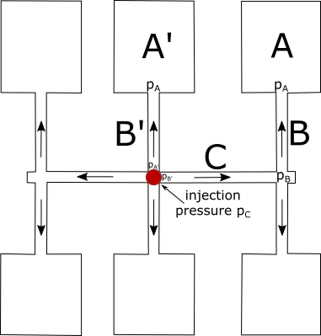

1. Compute the pressure $p_{A}$ using equation (2)

$$p_{2}=\frac{\sqrt[s]{Q\frac{s+2}{2Wh^{2}}}}{h}mL+p_{1}$$

*Where:*

$p_{2}=p_{A}$*,*

$Q=30 cm^{3}/s$*,*

$s=2.049$*,*

$W=10 cm$*,*

$2h=1 cm$*,*

$m=1311.2 Pa∙s$*,*

$L=10 cm$*,*

$p_{1}=p_{C}=32 MPa$*, is the packing pressure.*

$$p_{2}=\frac{\sqrt[2.049]{30 cm^{3}/s\frac{2.049+2}{2\left(10cm\right){\left(0.5cm\right)}^{2}}}}{0.5 cm}\left(1311.2Pa∙s\right)\left(10cm\right)+22MPa$$

$$p_{2}=\frac{\sqrt[2.049]{0.3×{10}^{-6} m^{3}/s\frac{2.049+2}{2\left(0.01m\right){\left(0.005m\right)}^{2}}}}{0.005 m}\left(1311.2Pa∙s\right)\left(0.1m\right)+22MPa$$

$$p_{2}=\frac{\sqrt[2.049]{0.3×{10}^{-6} m^{3}/s\frac{2.049+2}{2\left(0.01m\right){\left(0.005m\right)}^{2}}}}{0.005 m}\left(1311.2Pa∙s\right)\left(0.1m\right)+22000kPa$$

$$p_{2}=22040.437 kPa$$

$$p_{A}=22040.437 kPa$$

1. Compute the pressure $p_{B}$ using equation (1)

$$p_{2}=\sqrt[s]{Q\frac{s+3}{π R^{s+3}}}2mL+p_{1}$$

*Where:*

${2p}_{2}=p_{B}$*, we are multiplying by two since the pressure in $p_{B}$ is divided into two equal cavities (up and down).*

$Q=30 cm^{3}/s$*,*

$s=2.049$*,*

$R=1 cm$*,*

$m=1311.2 Pa∙s$*,*

$L=10 cm$*,*

$p_{1}=p_{A}=32040.437 kPa$*.*

$$p_{2}=\sqrt[2.049]{\left(30cm^{3}/s\right)\frac{2.049+3}{π {\left(1cm\right)}^{s+3}}}2\left(1311.2Pa∙s\right)\left(10cm\right)+22040.437kPa$$

$$p_{2}=22058.806 kPa$$

$$p_{B}={2p}_{2}=44117.612kPa$$

and

$${p_{A}'=p}_{2}=22058.806 kPa$$

1. Compute the pressure $p_{B}^{'}$ using equation (1)

$$p_{2}=\sqrt[s]{Q\frac{s+3}{π R^{s+3}}}2mL+p_{1}$$

*Where:*

$p_{2}=p_{B}^{'}$*,*

$Q=30 cm^{3}/s$*,*

$s=2.049$*,*

$R=1 cm$*,*

$m=1311.2 Pa∙s$*,*

$L=26 cm$*,*

$p_{1}=p_{B}=64117.612 kPa$*.*

$$p_{2}=\sqrt[2.049]{\left(30cm^{3}/s\right)\frac{2.049+3}{π {\left(1cm\right)}^{s+3}}}2\left(1311.2Pa∙s\right)\left(26cm\right)+44117.612kPa$$

$$p_{2}=44264.536 kPa$$

$$p_{B}^{'}=p_{2}=44264.536kPa$$

1. Finally, the injection pressure is given by $p_{C}$:

$$p_{C}=2p_{A}^{'}+2p_{B}^{'}$$

$$p_{C}=2\left(22058.806kPa\right)+2\left(44264.536kPa\right)$$

$$p_{C}=132.64 MPa$$

## Ask yourself if the result is reasonable

As stated by Farotti et al. [5] the typical packing pressure is about 32 MPa per cavity. The proper injection pressure depends largely on part size and configuration. Pressures usually range from 1,000 to 1,500 psi. Best results are obtained at higher pressures, up to about 75% of the press capacity. Pressures should be high enough to fill the part and to avoid problems with shrinkage, voids, sinks, and pigment dispersion. Too much pressure can cause parts to flash, burn, and stick in the mold.

## References

1] J.A. Dantzig, C.L. Tucker, Modeling in Materials Processing, Cambridge University Press, 2001. https://doi.org/10.1017/CBO9781139175272.

[2] T. Osswald, N. Rudolph, T. Osswald, N. Rudolph, Generalized Newtonian Fluid (GNF) Models, Polym. Rheol. (2014) 59–99. https://doi.org/10.3139/9781569905234.003.

[3] H. Zhou, Z. Hu, D. Li, Mathematical Models for the Filling and Packing Simulation, in: Comput. Model. Inject. Molding, John Wiley & Sons, Inc., Hoboken, NJ, USA, 2013: pp. 49–70. https://doi.org/10.1002/9781118444887.ch3.

[4] C. Fernandes, A.J. Pontes, J.C. Viana, A. Gaspar-Cunha, Modeling and Optimization of the Injection-Molding Process: A Review, Adv. Polym. Technol. 37 (2018) 429–449. https://doi.org/10.1002/adv.21683.

[5] E. Farotti, M. Natalini, Injection molding. Influence of process parameters on mechanical properties of polypropylene polymer. A first study., Procedia Struct. Integr. 8 (2018) 256–264. https://doi.org/10.1016/j.prostr.2017.12.027.

# Problem 2 (Capillary rheometer correction)

1. You have the following information from a capillary rheometer for a HDPE resin (this is real data so several runs were made at the same velocity due to possible variabilities in the instrument)

|  |  |  |  |  |  |  |  |
| --- | --- | --- | --- | --- | --- | --- | --- |
| Velocidad (in/s) | | Average load (lbf) for the L/D=40 die | | Average load (lbf) for the L/D=20 die | | Average load (lbf) for the L/D=10 die | |
| 0.061 | 170.3 | | 92.6 | | 55.9 | |
| 0.061 | 171.7 | | 92.6 | | 54.1 | |
| 0.307 | 420.5 | | 216.9 | | 121.3 | |
| 0.307 | 417.5 | | 214.4 | | 119.4 | |
| 0.614 | 579.1 | | 296.5 | | 164.6 | |
| 0.614 | 575.8 | | 294.1 | | 162.9 | |
| 3.07 | 848.4 | | 390.7 | | 261.6 | |
| 6.14 | 626.8 | | 360.6 | | 233.8 | |
| 6.14 | 623.6 | | 377.8 | | 264.3 | |
| 13.8 | 939.4 | | 552.4 | | 368.5 | |
| 18.4 | 1098.4 | | 640.3 | | 418.0 | |

* Some of the dimensions are:
* Barrel diameter 0.68 cm
* Capillary diameter: 0.05 inches
* Die Lengths: 2 in; 1 in; 0.5 in
* The piston moves at constant velocity (inches/second)
* The load is given pound force (lbf) and the force sensor is at the top of the piston.

You are asked to:

1. Get the real shear viscosity
2. The pressure at the entrance
3. The elongational viscosity

## *Rephrase the problem*

## List all the data provided.

## Make a list of the assumptions, justifying each of them.

## Write down an algorithm for the solution you are proposing.

## Solve the problem

## Ask yourself if the result is reasonable

## References